Toolkit version

Supporting prioritisation of mental health funding related to urgent and emergency care in the East of England

A practical toolkit for Integrated Care Systems and Sustainability and Transformation Partnerships

Lucy Hocking, Jennifer Bousfield, Evangelos Gkousis, Katherine Morley, Jon Sussex
RAND Europe
March 2021
Prepared for the Eastern AHSN (Academic Health Science Network)

Purpose and context of this practical toolkit
This toolkit has been prepared to help Integrated Care Systems and Sustainability and Transformation Partnerships (ICS/STPs) with planning priorities across mental health urgent and emergency care. It was commissioned, alongside developing a more detailed guide for ICS/STPs, by Eastern AHSN (Academic Health Science Network) and NHS England and Improvement.
The main guide provides a more thorough description of a structured and pragmatic approach to prioritising the allocation of resources across mental health urgent and emergency care and to monitoring the impact of the projects that are resourced. Particular attention is given to the development and use of logic models to clarify a process for how desired outcomes can be achieved. The toolkit and the full guide both draw on discussion with ICS/STPs in the East of England.
This toolkit brings together key practical resources from the guide. This toolkit has been developed as a practical workbook to help develop logic models whilst determining spending planning priorities within mental health urgent and emergency care. This is an action-focused booklet providing templates and worked examples of logic models for you to use to develop the spending planning priorities.
In the toolkit, we cover:
- What to consider for practical prioritisation
- Multi-criteria decision analysis
- Evidencing, monitoring and evaluating projects: logic models
- Useful resources
The toolkit should not be construed as a comprehensive review of, nor the final word on, possible approaches to prioritisation or logic model development. It is a distillation of the authors' knowledge and experience, strengthened and refined by discussions with ICS/STPs in the East of England.

What to consider for practical prioritisation
Whether explicitly or implicitly, ICS/STPs, and commissioners and planners of services for NHS patients more generally, are constantly having to prioritise the use of resources. Worthwhile opportunities almost always exceed the funds and other resources available. There are many approaches to prioritising the use of NHS resources. Chapter 2 of the full guide provides further detail.
We propose a proportionate and pragmatic approach that can be used, even when time is short, to prioritise different options for resource use for mental health urgent and emergency care. There are four main steps to take, as illustrated in Figure 1.
Figure 1: A pragmatic process for prioritising options for using resources
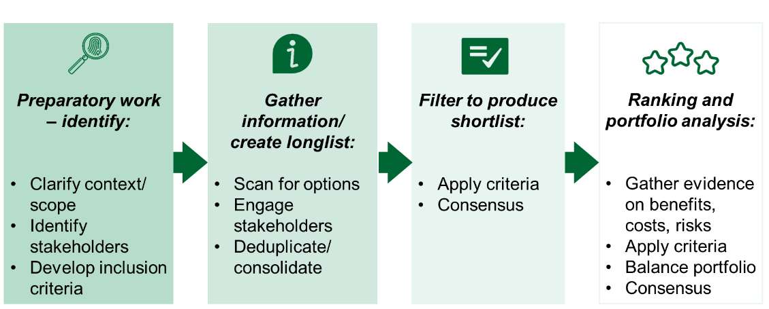
Source: RAND Europe
The first step is to be clear about the scope of the prioritisation exercise (e.g. mental health urgent and emergency care); the range and number of stakeholders whose views need to be taken into account given the scope of the exercise and the time available for prioritisation (e.g. service users, commissioners, providers); and what it is you are trying to achieve, meaning the criteria for determining whether one option is better than another.
The second step requires identifying, with your stakeholders, the full longlist of options you could spend your available resources on – while being alive to the possibility that stakeholders may be describing the same option in different ways, so you will need to look out for different versions of the same thing.
The third step is to filter the longlist down to a shortlist, achieving consensus across stakeholders where possible.
The final step is then to rank the shortlisted options, again seeking consensus across stakeholders where possible, so that you know which are the most important to pursue, depending on the extent of the available resources.
Table 1 gives a checklist of questions to consider when thinking about how to approach prioritisation, as outlined in Figure 1.

Table 1: Checklist for approaching the prioritisation process
Key considerations/questions |  | Tick when complete
Stage 1: Preparatory work
1 | What is within scope for the resources you have available?
2 | Are there specific rules you have to adhere to, e.g. are you prioritising options for spending funds awarded for a certain type of service or population?
3 | Which type of stakeholders would be useful to involve in discussing options for where to direct the resources and how to prioritise those options?
4 | How could service users and/or the public be involved in discussions around options for where to direct the resources and how to prioritise those options (if appropriate)?
5 | Based on the above steps, can inclusion criteria be developed to create a long list of potential projects to support? The same criteria will be applied later on to determining priorities between options.
Stage 2: Gather information and create your longlist
6 | Can you collect ideas for projects that could be funded with the resources available? Ideas can come from multiple sources, e.g. existing ideas that have not yet been funded, horizon scanning exercises to generate new ideas, engaging with stakeholders from steps 3 and 4 to identify new ideas.
7 | From the ideas generated in step 6, can you collate a long list of possible projects that could be funded with the resources available, based on your inclusion criteria developed in step 5? In doing so, you will need to check for essentially similar ideas and remove duplications.
Stage 3: Filter the longlist to a shortlist
8 | Can you reduce the longlist from step 7 into a shorter list? Are any items on the list clearly superior to others in meeting the criteria from step 5?
9 | How do you know, and how can you show that these are worthwhile ideas? Answering this question step can be supported by developing high-level logic models for each potential project to explore the resource intensiveness and expected outputs/outcomes of each. See the checklist in the next section for further support with this.
10 | Is there a way to involve the stakeholders from steps 3 and 4 in identifying ideas to take forward from the longlist to the shortlist, achieving consensus about that if possible?
Stage 4: Ranking and portfolio analysis
11 | For each of the ideas in your shortlist, can you gather evidence on their benefits, costs and risks?
12 | For the ideas on your shortlist, based on the evidence you collected in step 10, can you rank these in terms of their net benefits relative to their financial costs to determine which projects to resource?
13 | Given the resources available to you, how far down the ranking are you able to resource ideas on the shortlist? Would the resulting portfolio be sufficiently balanced overall – and if not, do you need to promote any of the lower-ranked options?
14 | Once you have decided which options to resource, could you think about ways of monitoring and evaluating whether they have been successful? See the checklist in the next section for questions to consider when drafting a logic model.
Source: RAND Europe

Multi-criteria decision analysis (MCDA)
Various techniques exist for combining all benefits and costs of an option for using resources so that options can be compared with one another even when they cannot all be expressed in the same financial metrics. These techniques are generally some variant of 'multi-criteria decision analysis (MCDA)'.
Box 1 summarises key points about MCDA methods. The time and data inputs required by MCDA are non-negligible. Still, they can be tailored to the scale of the resource commitments being considered and the time available to make the prioritisation decisions.
Box 1 – Multi-criteria decision analysis (MCDA)
- MCDA is an umbrella term to describe a collection of formal approaches that take explicit account of multiple criteria to prioritise between options for resource use.
- MCDA improves transparency and consistency of decisions.
- The main steps in MCDA are, in essence, to:
- Determine the criteria that are relevant to deciding between the options (in the context of this guide: options for using resources for urgent and emergency mental health care).
- Decide how each criterion is to be measured or scored – are there natural units such as £, of numbers of staff trained or rating scales (e.g. a scale from 1–5 according to how well a qualitative benefit is achieved, e.g. patient experience of care) – and determine those measures/scores for each option.
- Decide the relative weight to be placed on each criterion.
- Determine the implied order of preference (ranking) across the options, either approximately (is it a high, medium, low priority) or more precisely (with a weighted score for each option equal to the sum of its score against each criterion multiplied by the weight placed on that criterion).
- Note the extent of any uncertainty about the ranking of any of the options.
- Ideally, each step would be taken in discussion with stakeholders – a practical approach is to undertake all steps in a workshop with stakeholders.

Table 2 provides a checklist that can be used when designing, reporting and assessing MCDA in healthcare.
Table 2: Checklist for designing, reporting and assessing MCDA studies
MCDA step | Recommendation
1. Defining the decision problem | a. Develop a clear description of the decision problem
 | b. Validate and report the decision problem
2. Selecting and structuring criteria | a. Report and justify the methods used to identify criteria
 | b. Report and justify the criteria definitions
 | c. Validate and report the criteria
3. Measuring performance | a. Report and justify the sources used to measure performance
 | b. Validate and report the performance metrics
4. Scoring alternatives | a. Report and justify the methods used for scoring
 | b. Validate and report scores
5. Weighting criteria | a. Report and justify the methods used for weighting
 | b. Validate and report weights
6. Calculating aggregate scores | a. Report and justify the aggregation function used
 | b. Validate and report results of the aggregation
7. Dealing with uncertainty | a. Report sources of uncertainty
 | b. Report and justify the uncertainty analysis
8. Reporting and examining findings | a. Report the MCDA method and findings
 | b. Examine the MCDA findings
Source: Adapted by the authors from Marsh et al. (2016)

Evidencing, monitoring and evaluating projects: logic models
'Logic model' is a generic term that describes visual representations of any project/programme, linking their contexts, assumptions, inputs, implementation chains and outcomes/impacts. They are a helpful tool to support the prioritisation process by evidencing options to be considered, informing the shortlisting and ranking of options, and providing a framework for monitoring and evaluating projects that are implemented.
Logic models can vary from being very simple to highly complex, depending on the type of programme/project and how much information needs to be conveyed in one place. For example, a logic model can be developed summarising the pathway of one or multiple projects, as well as for an overall programme of work.
Logic models generally follow a set template as outlined in Figure 2 and on the next page. Logic model diagrams are intended to be understood by reading them from left to right (i.e. from Inputs to Outcomes). However, when developing logic models, it can be more helpful to work from the right to the left of the model, i.e. starting with thinking about the desired Outcomes (the ultimate aim of the activity). Then working back through the Outputs that are to yield those outcomes, to the Activities that could produce those outputs, and then the Inputs needed for those activities.
Figure 2: Template for a logic model
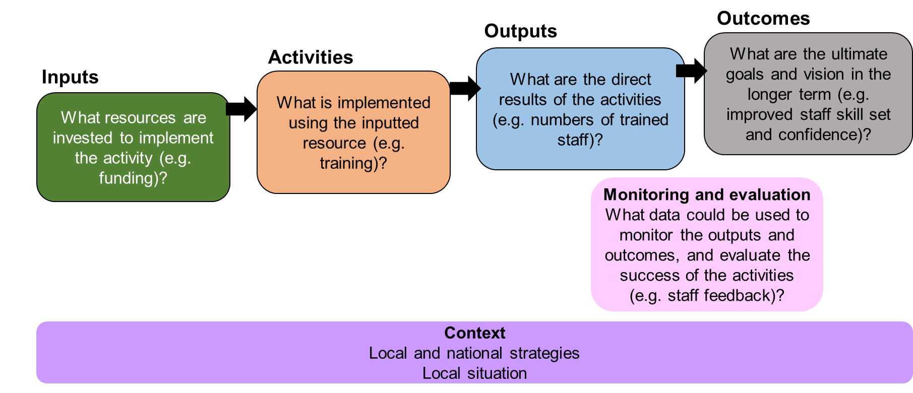
Source: RAND Europe

Inputs
The inputs are the resources used to develop, set up and run the initiative. Inputs could include, for example, a certain type of funding, new staff resource, or access to infrastructures such as buildings and equipment.
Activities
This section describes the different types of activities (e.g. initiatives, interventions, processes) that can be put in place using the resource in the input section. This could be a range of different activities, such as staff training, offering a new service (or expanding an existing one), or introducing new technology.
Expected outputs
The outputs describe the expected direct products of the activities, such as the number of staff trained if a new training package is implemented or the number of users of a new service like a mental health support helpline.
Expected outcomes
The outcomes describe the expected ultimate aims of the initiatives and are often realised on a more medium-to-long-term basis than the outputs. For example, improved mental health in the population, staff having improved skills, or healthcare targets being met.

Checklist for developing a logic model
The approach to creating a logic model is straightforward. Table 3 provides a checklist for developing a logic model for a single project or multiple projects together.
Table 3: Checklist for developing a logic model to evidence and evaluate project(s)
Key considerations/questions |  | Tick when complete
Step 1: Outcomes
1 | What do you ultimately want your project(s) to achieve within the resources you have available?
2 | What are the particular needs of the population you are trying to support?
3 | Where and what are the pressures in the system that your project(s) could help alleviate?
4 | What metrics or data could you use to monitor whether each outcome is achieved?
Step 2: Outputs
5 | What outputs would be produced to achieve these outcomes?  E.g. trained staff, ability to offer a service 24/7, new protocols.
6 | What metrics or data could you use to monitor how far these outputs are produced?
Step 3: Activities
7 | What activities could you implement to produce these outputs?  N.B. There may be more than one way of producing such outputs.
Step 4: Inputs
8 | What resources/how much funding do you have available?
Step 5: Wider context and assumptions
9 | Can you identify the external factors that may influence your project but are not necessarily within your control (e.g. national policy, broader strategies, local priorities, external events)?
10 | What assumptions are you making, whether explicitly or implicitly, when mapping how the activities lead to the intended outputs and how those outputs lead to the intended outcomes? (E.g. for a new training package aiming to improve the knowledge and confidence of staff working with a particular group of service users, individuals need to have the time and willingness to attend the training.)
Source: RAND Europe

Example logic model
In the full guide, we have developed logic models for six programme areas of work relating to urgent and emergency mental health care: children and young people; mental health liaison; crisis alternatives; high impact support; older adults; and drug and alcohol misuse. The same process can equally well be used to develop a logic model for any other programme area.
For each of the six programme areas, we provide in the Guide a full logic model diagram, a worked example through one possible pathway within the logic model, and a box listing the aspects to consider when putting a logic model together.
In this toolkit, we provide, as a template, these resources from just one of the programme areas, namely children and young people.

Figure 3: Worked example of a pathway within the children and young people logic model
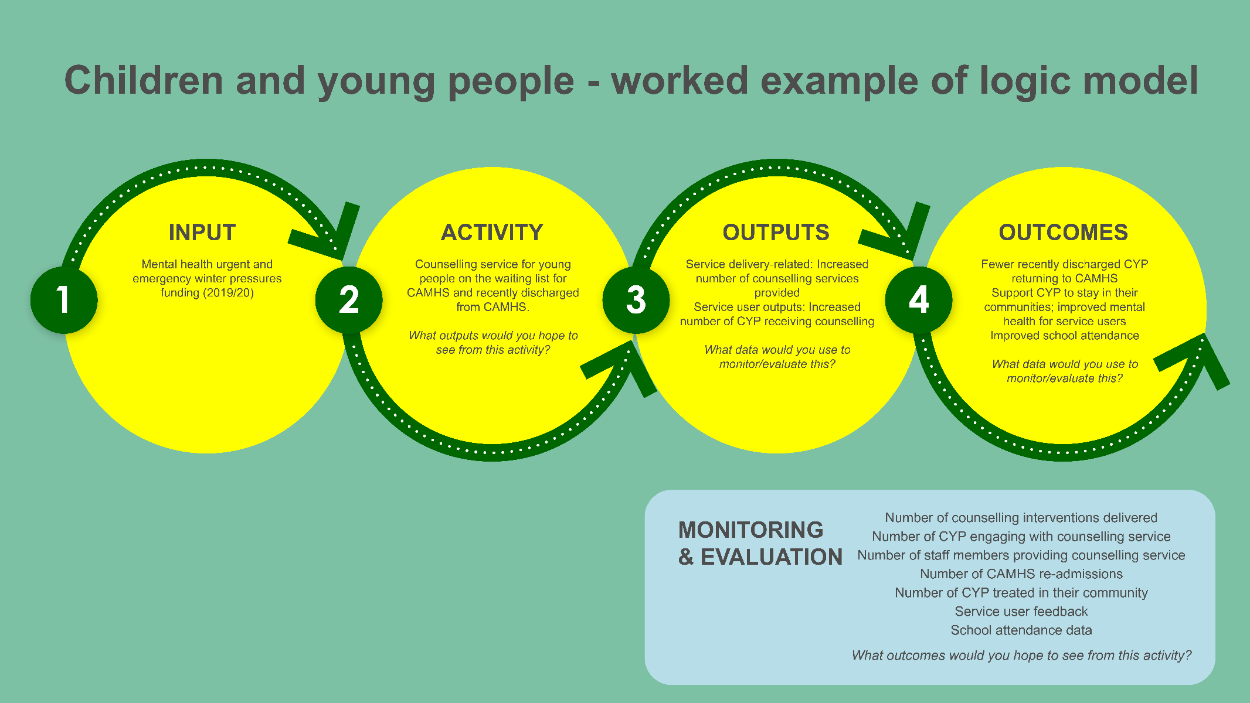
Source: RAND Europe

Box 2 – What to consider when developing your logic model for children and young people
When designing a logic model, it is often useful to work from the right- to the left-hand side (from outcomes to activity, as the input (i.e. available resource) is often pre-determined):
- Think about your vision (outcome) for the project. What do you ultimately want to achieve, within the resources you have available? It may be useful to think about the particular needs of the young population in your area and where the pressures are in the system. For example, do the young people in your area need additional support after being discharged from CAMHS, or is a triage service needed in A&E departments to direct young people to more appropriate services?
- Working back from this vision, think about what needs to be put in place to reach the outcome (i.e. the outputs). Do you need additional staff to offer community mental health support for young people or do you want a greater number of young people to access counselling services?
- To achieve these outputs, you can then move to thinking about the activities. What projects could you put in place for these outputs to occur, to ultimately lead to your desired outcome (within your available resources)? For example, could a new/expanded counselling service be set up specifically available for children and young people, or does a new staff training package need to be developed?
- Once you have thought about your outcome, output and activities, it is then useful to consider how you might monitor and evaluate the project to see if it leads to the outputs/outcome you are looking for. For example, you could monitor the number of staff who have taken part in the new training package, or assess the changes in the mental health of the children and young people engaging with your new service. You could also use data from other services or national data, for example, data from schools or the MHSDS.
- After you have developed your logic model using the steps above, the final steps are to consider the wider context in which you are implementing your project and the assumptions you hold.
  - While there is often little you can do to change the wider context in which your project is being implemented, it is helpful to consider how these external factors may influence your outputs and outcomes. For example, is there a new policy or programme being implemented that will direct additional resources to young people’s mental health in your area, or are there wider mental health priorities in your area?
  - In linking your activity to the outputs and outcomes, you are making a number of assumptions and it can be useful to list these to understand where you may come across challenges in reaching your outputs and outcomes. For example, for a new young people’s counselling service to improve the mental health of users, there needs to be staff with the time available and the appropriate training to offer the service.

Figure 4: Children and young people logic model
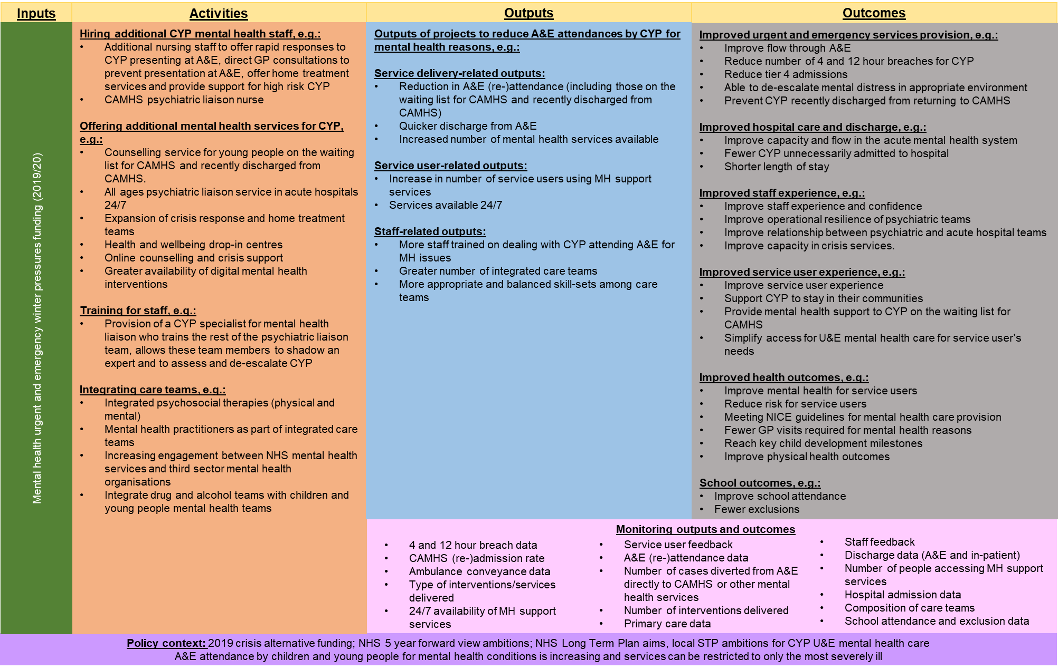
Source: RAND Europe

Useful resources
Here, we provide a list of other resources beyond the full guide and this toolkit that you may find helpful when thinking about prioritising your resources and/or monitoring and evaluating your projects.
- Prioritisation of resources – the Public Health England webpage provides clear, concise and useful material that may be helpful to other areas, including mental health urgent and emergency care. Some local examples follow, plus the H.M. Treasury guidance on appraisal of options:
  - Public Health England. Overview of the prioritisation framework. 2019. https://www.gov.uk/government/publications/the-prioritisation-framework-making-the-most-of-your-budget/overview-of-the-prioritisation-framework
  - NHS East and North Hertfordshire CCG. Commissioning prioritisation and quality impact assessment. 2019. https://www.enhertsccg.nhs.uk/sites/default/files/documents/Apr2017/Prioritisation-Framework-March-2017-FINAL-v1.6.pdf
  - NHS West Suffolk CCG. Clinical prioritisation process. https://www.westsuffolkccg.nhs.uk/wp-content/uploads/2013/01/Clinical-Prioritisation-Process1.pdf
  - NHS Birmingham and Solihull CCG. Policy for the prioritisation of healthcare resources. 2019. https://www.birminghamandsolihullccg.nhs.uk/about-us/publications/policies/2511-prioritisation-of-healthcare-resources-policy/file
  - H.M. Treasury. 2020. The Green Book: appraisal and evaluation in central government. https://www.gov.uk/government/publications/the-green-book-appraisal-and-evaluation-in-central-governent
- Logic model development:
- Public Health England. Introduction to logic models. 2018. https://www.gov.uk/government/publications/evaluation-in-health-and-well-being-overview/introduction-to-logic-models
- H.M. Treasury. 2020. The Magenta Book. https://www.gov.uk/government/publications/the-magenta-book
- Better Evaluation. Using logic models and theories of change better in evaluation. 2017. https://www.betterevaluation.org/en/blog/Using-logic-models-and-theories-of-change-better-in-evaluation
- The following page provides a blank logic model worksheet that you can fill out.

Source: RAND Europe
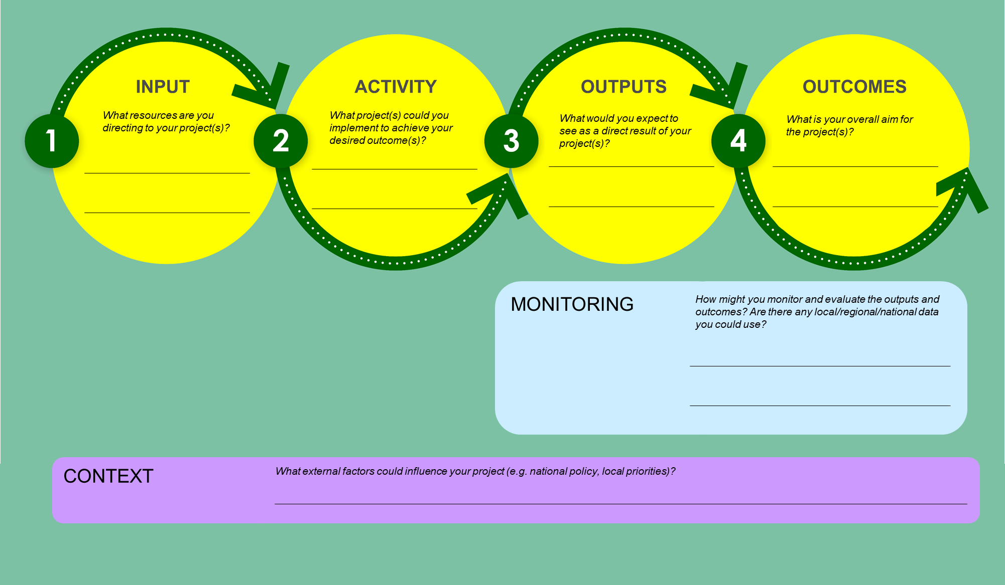

Devlin, N, and J Sussex. Incorporating multiple criteria in HTA – methods and processes. London: Office of Health Economics, 2011.
Sources: Devlin, N, and J Sussex. Incorporating multiple criteria in HTA – methods and processes. London: Office of Health Economics, 2011; Marsh, K, et al. Multiple Criteria Decision Analysis for Health Care Decision Making-Emerging Good Practices: Report 2 of the ISPOR MCDA. Value Health. 2016;19(2):125-37; Public Health England. Overview of the prioritisation framework. 2019. https://www.gov.uk/government/publications/the-prioritisation-framework-making-the-most-of-your-budget/overview-of-the-prioritisation-framework; NHS Birmingham and Solihull CCG. Policy for the prioritisation of healthcare resources. 2019. https://www.birminghamandsolihullccg.nhs.uk/about-us/publications/policies/2511-prioritisation-of-healthcare-resources-policy/file.
Marsh, K, et al. Multiple Criteria Decision Analysis for Health Care Decision Making-Emerging Good Practices: Report 2 of the ISPOR MCDA. Value Health. 2016;19(2):125-37.
Public Health England. Introduction to logic models. [Online] 2018. https://www.gov.uk/government/publications/evaluation-in-health-and-well-being-overview/introduction-to-logic-models; HM Treasury. Magenta Book: Central Government guidance on. London: 2020.
HM Treasury (2020)
Public Health England (2018)

